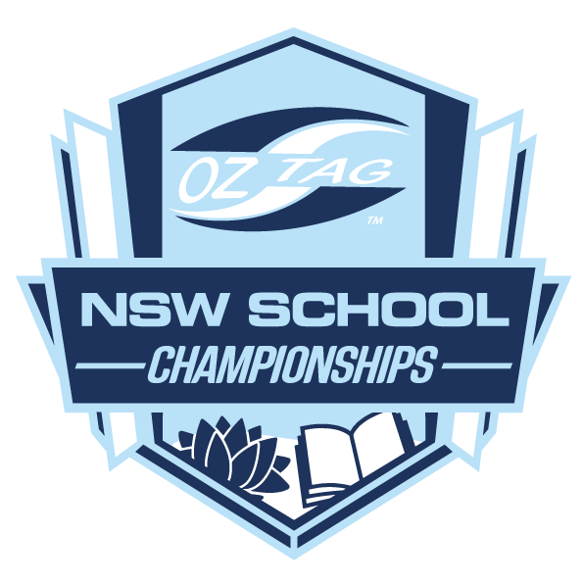
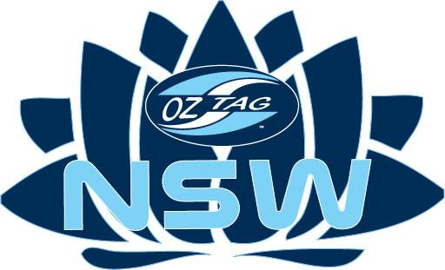

NSW OZTAG
Northern Sydney

SECONDARY SCHOOLS REGIONALS

SCHOOL INVITATION / NOMINATION
NSW Oztag would like to invite your School to play in the Northern Sydney Regional Oztag Tournament. Please find attached a team nomination form listing the divisions offered.

Date | Tuesday 17th May 2022
Time | Kick Off 8:00am
Venue | Artarmon Reserve, Artarmon
Entry Fee | $100 Team

Please see the attached Official Regional Nomination form and return to NSW Oztag by email jordan@oztag.com.au.

Once we have received your school’s nomination form a confirmation email will be sent and further information will be forwarded on to your school.

SCHOOL NAME:
CONTACT NAME: |  |  | PH:
EMAIL:
Division | Year 7/8 | Year 9/10 | Year 11/12
Girls
Boys

Please indicate in the table above the number of teams that you are likely to enter in each division.
Note: A maximum of 1 team per school in each division.

Please return this Nomination Form before Tuesday 10th May.

