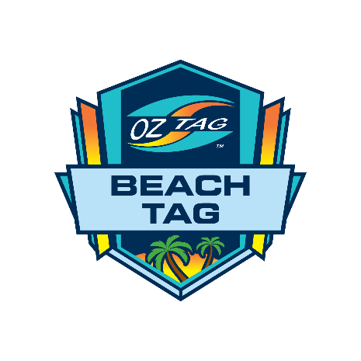

**Venue:** Maroubra Beach

**Date:** Saturday 18th February 2023

**Team Nominations**

* Nominations and team payment must be submitted to AUSTRALIAN OZTAG by February 3rd 2023
* Entry fee is $60 per player
* Teams may play a maximum of 12 players and a minimum of 8 players.
* Teams must be in a uniform (same colour t-shirt / singlet with a number on the back)

|  |
| --- |
| **Team Name:** |
| **Contact/Coach:** |
| **Phone Number:** |
| **Email:** |

|  |  |  |
| --- | --- | --- |
| **Division** | **Please Tick** | **No. Players** |
| Men’s Open |  |  |
| Mixed Open |  |  |

Return to : beachtag@oztag.com.au

**Cheque:**

Made payable to Australian Oztag

**Direct deposit**

Oztag Tournament (ABN: 44601178787)

BSB: 082-367

Account Number: 74152 1647

National Australia Bank

**NB Indicate your Team Name & Division when direct depositing**

Payment must be made 14 Days Prior to the tournament in full or your team will be removed.