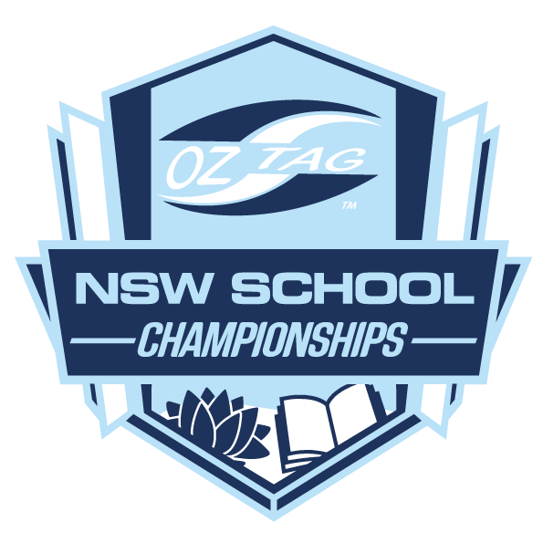

NSW OZTAG

SOUTH COAST NSW

Primary School Gala Day

SCHOOL INVITATION / NOMINATION
NSW Oztag is hosting the South Coast Primary Schools Gala Day and would like to invite your school to attend. The Primary School Gala Day gives all students the opportunity to play Oztag and have fun with their school friends, while competing against other schools in their region.

Date | Thursday November 16th, 2023
Venue | Thomas Dalton Park, Fairy Meadow
Entry Fee | $50 per team (Cost Covers medals, referees, First Aid & Ground Hire)

To enter your team, fill out the Nomination Form below and return to jordan@oztag.com.au
Once we have received your school’s Nomination Form, a confirmation email will be sent and further information will be forwarded onto your school.
If you have any questions, please call us on 9526 8633.
SCHOOL NAME:
CONTACT NAME: |  |  | PH:
EMAIL:

Please note- schools are only allowed to enter one team per division,
Division | Year 3/4 | Year 5/6
Girls
Boys

IMPORTANT NOTES
- Maximum 12 Players per team, players can only play in one division.
- There will be NO REFUNDS given to any teams/school that withdraws 7 days prior to the competition.
- There will be official Oztag photography at the tournament, if any students do not want to be photographed please notify when returning the nomination form

