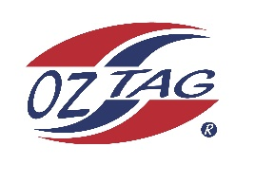

2023 Engadine/Heathcote
Under 12s Boys Representative

Congratulations to the following players selected in the under 12s Boys squad to represent Heathcote/Engadine.

1 | Jayden Borg
2 | Cooper Gombi
3 | Rory Grimison
4 | Jax Hamer
5 | Ryan Walker
6 | Curtly Lloyd
7 | Harlan Taylor
8 | Dash Earnshaw
9 | Charlie Cooper
10 | Max Bayliss
11 | Josh Wilson
12 | Finn Vaccaro
13 | Blake Noble
14 | Kobi Phillips
15 | Tom Ashley
16
 | Shadows (in no particular order)
17
18
19
20

COACH: Ben Borg – 0405 523 666

