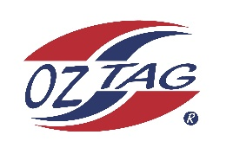

2023 Engadine/Heathcote
Under 10s Girls Representative

Congratulations to the following players selected in the under 10s Girls squad to represent Heathcote/Engadine.

1 | Mia Cooper
2 | Maddison Fitzgerald
3 | Jonesy Hollands
4 | Evie Ingram
5 | Indi Lyon
6 | Ava McBride
7 | Harper McLoughlin
8 | Ashlyn O’Riley
9 | Mila Osmand
10 | Meg Payne
11 | Imogen Palmer
12 | Harper Rea
13 | Luca Starr
14 | Abigail Skinner
15 | Maddy Woolley
16 | Lola Williams
 | Shadows (in no particular order)
17
18
19
20

COACH: Jared Starr – 0421 079 159
Email: jared@active8pooltables.com.au

