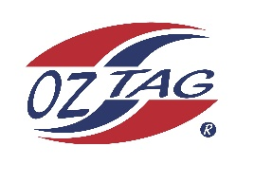

2023 Engadine/Heathcote
Under 11 Girls Representative

Congratulations to the following players selected in the under 11 Girls squad to represent Heathcote/Engadine.

1 | Harper Chapman
2 | Halle Bostick
3 | Dylan Hamer
4 | Tilda Junghans
5 | Ruby Ablet
6 | Bronte Driver
7 | Evie Cousemacker
8 | Jazmin White
9 | Sasha Zinato
10 | Amikyah Tomlin
11 | Paige Agnew
12 | Sienna Croft
13 | Lyla Oake
14 | Willow Rea
15 | Seren Hiles-Fraser
16 | Shae Denyer
 | Shadows (in no particular order)
17
18
19
20
Division: 11 Girls

Coach/s: Gina Bostick
Phone: 0418450952
Email: gg.bostick@bigpond.com

Coach/s: Drew Cousemacker
Phone: 0416155338
Email: drew@cousemackergroup.com.au

Manager: Spencer White
Phone: 0413359370
Email: spencer@axisplumbing.com.au

