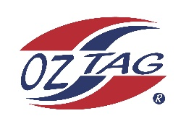

2023 Engadine/Heathcote
Under 17 Girls Representative

Congratulations to the following players selected in the under 17 Girls squad to represent Heathcote/Engadine.

1 | Brydie Kadziela
2 | Sophie Weppler
3 | Ava Lavender
4 | Freya Scully
5 | Jade Cousemacker
6 | Phoebe King
7 | Ella Gair
8 | Brook Campbell
9 | Coco Fleming
10 | Sahara Ingram
11 | Ellie Darlington
12 | Ella Roberts
13 | Ava Hardy
14 | Chynna Hardy
15 | Lauren Akins
16 | Delaney Gwyn
 | Shadows (in no particular order)
17 | Milli Duncan
18 | Brook Collins
19 | Ella Bilsborough
20 | Chanel Smith
21 | Samantha Rylands
Division: 17 Girls

Coach/s: Jordan Hollis
Phone: 0414425712
Email: jordan@oztag.com.au

Coach/s: Drew Cousemacker
Phone: 0416155338
Email: drew@cousemackergroup.com.au

Manager: Natasha Hardy
Phone: 0424207351
Email: natashahardy1@bigpond.com

