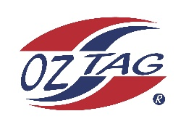

2023 Engadine/Heathcote
Under 9s Girls Representative

Congratulations to the following players selected in the under 9s Girls squad to represent Heathcote/Engadine.

1 | Cleo Ingram
2 | Essie Junghuns
3 | Waverley Tomlin
4 | Matilda Smith
5 | Blayke Oake
6 | Poppy Neville
7 | Holly Fordyce
8 | Piper Harlow
9 | Addison Schafer
10 | Lola Lovell
11 | Ellie Phillips
12
13
14
15
16
 | Shadows (in no particular order)
17
18
19
20

More players required – Please contact Grant or Erin.
COACH: Grant Ingram – 0407 880 949
Email: grantos8@hotmail.com
MANAGER: Erin Ingram – 0414 952 139
Email: erinsimone@hotmail.com

