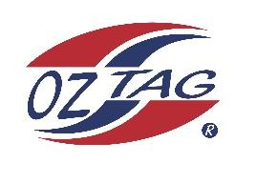

2023 Sutherland Shire Stingrays
Under Boys 12s Representative

Congratulations to the following players selected in the under 12s team to represent Sutherland Shire Stingrays.

 | Name
1 | Darcy Wilson
2 | Jaxon Sorensen
3 | Henry O’Flynn
4 | Harley Gardner
5 | Zuma Wever
6 | Finn Thompson
7 | Manny Hinton
8 | Jayden Borg
9 | Kai Wheatstone
10 | Isaac Bevan
11 | Phoenix Black
12 | Tyson Sedhom
13 | Xavier Terides
14 | Brax Lemke
15 | Jaxen Tickle
16 | Hunter Aston
17 | Liam Brennan
18
19
20

Division: Boys 12’s
Coach/s: Malyk Sedhom \ Taj Wever
Phone: Contact Manager
Email: Contact Manager

Manager: George Sedhom
Phone: 0400666060
Email: george@au-rmt.com

