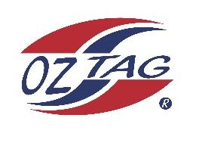

2023 Sutherland Shire Stingrays
Under Girls 10 Representative

Congratulations to the following players selected in the under 10 team to represent Sutherland Shire Stingrays.

 | Name
1 | Abigail O’Flynn
2 | Cleo Elsdon
3 | Chloe Punn
4 | Ella Sweeney
5 | Estelle Raftery
6 | Eva Anasis
7 | Havana Pallister
8 | Koa Barbuto
9 | Liberty Athos
10 | Lily Rikihana
11 | Luara McKinlay
12 | Mayah Tanko
13 | Mia Cooper
14 | Scarlett Tracy
15 | Victoria Trajcevski
16 | Zeldi Cilliers
17 | Sia Owsnett
18 | Ruby Somerville
19 | Chloe Lucas
20 | Isla Gladman

Division: Girls 10’s
Coach/s: Chad & Kelly Barbuto
Phone: 0404 354 579
Email: kelflemo@hotmail.com

Manager: Taryn O’Flynn
Phone:0416 173 329
Email: Taryn.Evans1@det.nsw.edu.au

