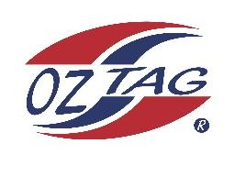

2023 Sutherland Shire Stingrays
Under 17 Boys Representative

Congratulations to the following players selected in the under 17 Boys team to represent Sutherland Shire Stingrays.

 | Name
1 | Ryan Wotton
2 | Rocco Hagan
3 | Zane Bell
4 | Zane Walker
5 | Rex Prosser
6 | Kailan Rehayem
7 | Taj Wever
8 | Max Halloran
9 | Kobe Sorenson
10 | Levi Dowling
11 | Bailey Leach
12 | Seb Newman
13 | Kobe Lillis
14 | Zac Boyle
15 | Cooper Wooley
16 | Kai Boyle
17 | Finn McMahon
18
19
20

Division: Boys 17s
Coach/s: Jason Dorahy & Luke Wever
Phone: 0414 272 681, 0400421657
Email: Jason.dorahy@gmail.com / weverluke@gmail.com

Manager: Liz Wever
Phone:0413 342 224
Email: daisyandrew@gmail.com

