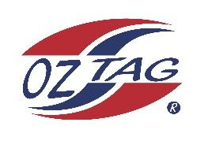

2023 Sutherland Shire Stingrays
Under Girls 17 Representative

Congratulations to the following players selected in the under 17 team to represent Sutherland Shire Stingrays.

 | Name
1 | Chloe Benton
2 | Brooke Campbell
3 | Jade Cousemacker
4 | Sienna Davey
5 | Eliza Feros
6 | Sienna Greck
7 | Ava Hardy
8 | Chynna Hardy
9 | Lily Hill
10 | Ryley Hulburt
11 | Ava Kimmorley
12 | Ava Lavender
13 | Kobe Maher
14 | Scarlet Salib
15 | Freya Scully
16 | Sophie Weppler
17
18
19
20

Division:
Coach/s: Angela & Matt Davey – Jordan Hollis
Phone: 0404 494 440
Email: angdavey72@gmail.com

Manager: Leah Salib
Phone: 0400 101 214
Email: ltinningsalib@westpac.com.au

