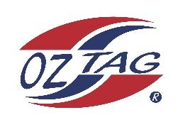

2023 Sutherland Shire Stingrays
Under 16 Girls Representative

Congratulations to the following players selected in the under 16 Girls team to represent Sutherland Shire Stingrays.

 | Name
1 | Summer Anderson
2 | Mia Bishop
3 | Belle Cheetham
4 | Sofia Cutro
5 | Tameika Dorahy
6 | Poppy Fava
7 | Kahlea Fisher
8 | Gemma Hanley
9 | Brooklyn Kingi
10 | Keely Latta
11 | Zara Owsnett
12 | Taya Seldon
13 | Chloe Shephard
14 | Ella Sorensen
15 | Olivia Vanderlaan
16 | Keala Whetu
17 | Isabella Quilkey
18 | Georgia Rake
19 | Nevaeh Isaac
20

Division: 16 Girls
Coach/s: David Whetu (C) Cullen Whetu (AC)
Phone: 0423610417
Email: davidwhetu@outlook.com

Manager: Marnia Whetu
Phone: 0408446778
Email: marnia.whetu1976@gmail.com

