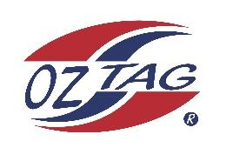

2023 Sutherland Shire Stingrays
Under 9 Boys Representative

Congratulations to the following players selected in the under U9 Boys team to represent Sutherland Shire Stingrays.

 | Name
1 | Harvey BARLOW
2 | Kai BAXTER
3 | Xavier BROWN
4 | Cruz COUPE
5 | Cooper EASTON
6 | Thomas HEGARTY
7 | Archie HERB
8 | Will JURD
9 | Zander NGAIKA
10 | Jay O’DELL
11 | Nash REDMAYNE
12 | Hunter SMALL
13 | Lennox SWAN
14 | Koby TICKLE
15 | Duke VAOTUUA
16 | Marley WAIWAI
 | Shadows in no particular order
17 | Boston KARAURIA-HENRY
18 | Ashton BRIDGMAN
19 | Ben KILMURRAY
20 | Dylan BENNETTS

Division: U9 Boys
Coaches: Wesley Waiwai & Jared Ngaika
Phone: 0405 963 908

Manager: Kylie Waiwai
Phone: 043 111 3949
Email: kylie-waiwai@hotmail.com

