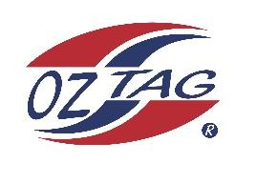

2023 Sutherland Shire Stingrays
Under 13 Boys Representative

Congratulations to the following players selected in the under 13’s team to represent Sutherland Shire Stingrays.

 | Name
1 | Austin Highett
2 | Bailey Silver
3 | Bear Laffan
4 | Corey Brown
5 | Cruz Wever
6 | Cooper Shephard
7 | Cooper Laverance
8 | Ethan Mullins
9 | Jack Mckevett
10 | Kash Lemke
11 | Koa Cooper
12 | Marshall Barlow
13 | Nate Horsey
14 | Roy Eisenhuth
15 | Randy Ennis
16 | Zane Smith
 | SHADOWS
17 | Lenny Bucher
18 | Cruz Morris
19 | Tyler Moon
20 | Brock Lampret

Coach:Paul Laffan
Phone:

Manager: Leanne Laffan
Phone:0409922773
Message to confirm your spot

