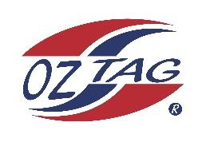

2023 Sutherland Shire Stingrays
Under 12 Girls Representative

Congratulations to the following players selected in the under 12’s team to represent Sutherland Shire Stingrays.

 | Name
1 | Leah Fowler
2 | Ruby Walker
3 | Isabella Komen
4 | Sophie Howsen
5 | Jasclyn Lemke
6 | Carpri McCarthy
7 | Mackenzie Franks
8 | Olive Maguire
9 | Georgia Laverance
10 | Halle Ferguson
11 | Lucy Watkins
12 | Beau Green
13 | Rylee Smith
14 | Mikayla Khan
15 | Felicity Barnes
16 | Zara Roper
 | SHADOWS (in no particular order)
17 | Ava Garvin
18 | Ella Gardiner
19
20

Coaches: Britney Vella and Michael MaCarthy
Phone: 0435 113 045 and 0424 824 032
Email: Britney.vella1@gmail.com and mickmcc82@hotmail.com

