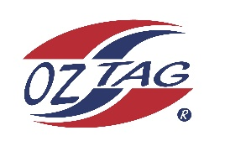
2022 Sutherland Shire Stingrays
Under 11 Boys Representative squad
Australian National Championships Cup Coffs Harbour

Congratulations to the following players selected in the under 11s boys squad to represent Sutherland Shire Stingrays.

1 | Brax Lemke
2 | Isaac Bevan
3 | Jackson Smith
4 | Zuma Wever
5 | Kai Wheatstone
6 | Carter Studdon
7 | Darcy Wilson
8 | Rory O’Brien
9 | Phoenix Black
10 | Tyson Sedhom
11 | Aidan Moran
12 | Xavier Terides
13 | Lachlan Hennessy
14 | Ryan Howard
15 | Patrick Flanagan
16 | Hunter Aston
 | Shadows (in no particular order)
17 | Lorenzo Barbuto
18 | Manny Hinton
19 | Jaxen Tickle
20 | Henry O’Flynn

Division: Boy’s 11s

Coach/s: George Sedhom \ Tim Wheatstone
Phone: 0400666060 \ 0408731904
Email: george@au-rmt.com \ twes68@gmail.com

Manager: TBA
Phone:
Email:

