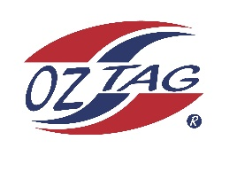
2022 Sutherland Shire Stingrays
Under 13 Boys Representative squad
Australian National Championships Cup Coffs Harbour

Congratulations to the following players selected in the under 13 Boys squad to represent Sutherland Shire Stingrays.

1 | Ashton Carrol
2 | Charlie Rap
3 | Dash Delaney-Fielding
4 | Benji Halloran
5 | Tyler Bowran
6 | Marshal Anderson
7 | Kade Wilson
8 | Fletcher Hick
9 | Xavier Young
10 | Kaden Anthony
11 | Jahree Kateen
12 | Lucas Cousemacker
13 | Hamilton Kingi
14 | Brodie Dorahy
15 | Curren Taper
16 | Kaike McKinlay
 | Shadows (in no particular order)
17 | Zac Redman
18 | Matt Ryan-Sweeney
19 | Kobe Kiellor
20 | Zaiden Green

Division: 13 Boys

Coach/s: Drew Cousemacker
Phone: 0416155338
Email: drew@cousemackergroup.com.au

Manager:
Phone:
Email:

