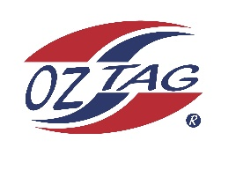
2022 Sutherland Shire Stingrays
Under Boys/Girls Representative squad
Australian National Championships Cup Coffs Harbour

Congratulations to the following players selected in the under 15 boys’ squad to represent Sutherland Shire Stingrays.

name

1 | Archie Hiles-Fraser
2 | Beau Duggan
3 | Brodie Ewings
4 | Cooper Smith
5 | Elijah Cooper
6 | Hayden Levin
7 | Jack Schumacher
8 | Jarvis Wever
9 | Joel Cornock
10 | Joshua Barr
11 | Kobi Porter
12 | Koby Wallace
13 | Liam Bova
14 | Logan Buddle
15 | Sam Gilroy
16 | Tate Nicholls
 | Shadows (in no particular order)
17 | Kye Connor
18 | Zac McPherson
19 | Isaac Dawson
20 | Jacob Benton

Division: 15 boys

Coach/s: Kieran levin
Phone: 0468 646 550
Email: kieranlevin1@outlook.com

Manager: Nicole Wallace
Phone: 0414 829 449
Email: russ.nic@bigpond.com

