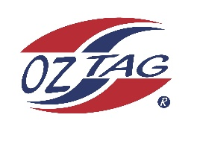
2022 Sutherland Shire Stingrays
Under 16 Boys Representative squad
Australian National Championships Cup Coffs Harbour

Congratulations to the following players selected in the under 16 Boys squad to represent Sutherland Shire Stingrays.

1 | Taj Wever
2 | Rocco Hagan
3 | Harry Perrau
4 | Ryan Davidson
5 | Max Halloran
6 | Cooper Shobrook
7 | Cooper Woolley
8 | Lewis Hood
9 | Zane Walker
10 | Rex Prosser
11 | Zac Boyle
12 | Zane Bell
13 | Kobe Sorensen
14 | Ryan Wotton
15 | Levi Dowling
16 | Finn McMahon
 | Shadows (in no particular order)
17 | Cameron Jones
18 | Nate Glendenning
19
20

Division: 16 Boys

Coach/s: Luke Wever/Jason Dorahy
Phone: 0400421657/0414272681
Email: Weverluke@gmail.com/jason@proficentservicesgroup.com.au

Manager: Luke Wever
Phone: 0400421657
Email: Weverluke@gmail.com

