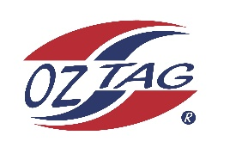

2023 Cronulla
Under 12’s Girls Representative

Congratulations to the following players selected in the
under 12’s Girls team to represent Cronulla.

1 | Felicity Barnes
2 | Emily Basanovic
3 | Imogen D’Apice
4 | Mackenzie Franks
5 | Olive Handel
6 | Isabella Komon
7 | Poppy Laing
8 | Sienna Lakomy
9 | Olive Maguire
10 | Indy Oldroyd
11 | Madison Palmer
12 | Tamika Pike
13 | Yalane Powell
14 | Semara Russell
15 | Allyra Sorensen
16 | Summer Sweeney
 | Shadows (in no particular order)
17 | Mikayla Beare
18 | Koda Boyle
19
20

Division: U12’s Cronulla Girls

Coach/s: Jason Russell
Phone: 0416934472
Email:

Manager: Louise Lakomy
Phone: 0416276766
Email:

