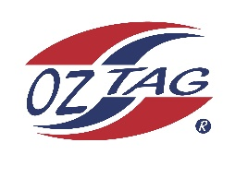
2023 Sutherland Shire Cronulla
Under 14 Girls Representative Squad
State Cup Coffs Harbour

Congratulations to the following players selected in the under 14 Girls to represent Cronulla.

1 | Kalani Anderson
2 | Eva Benton
3 | Emeline Bourke
4 | Ocean Bradley
5 | Brooke Carroll
6 | Noa Coupland
7 | Paige Debreczini
8 | Amalee Doyle
9 | Dolly Fava
10 | Haylee Hanley
11 | Lyla Hawksworth
12 | Matilda Kane
13 | Rhianna Karika
14 | Ashleigh L’Estrange
15 | Monique Marshall
16 | Tahli Weigand
 | Shadows in no particular order
17 | Sienna Best
18 | Saige Pritchard
19 | Kalarni Judd
20 | Talea Miller
21 | Taylor Galloway

Division: 14 Girls

Coach: Kim Carroll and Brett Carroll
Phone: Kim – 0408 115 350 Brett – 0416 248 125

Manager: Sarah Fava
Phone: 0417 423 785

