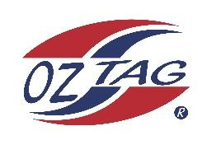
2022 Sutherland Shire Stingrays
Under Girls Representative squad
Australian National Championships Cup Coffs Harbour

Congratulations to the following players selected in the under 11s squad to represent Sutherland Shire Stingrays.

 | Name
1 | Michaela Jenkins
2 | Ruby Walker
3 | Isabella Komen
4 | Sailor Gurney
5 | Joscyln Lemke
6 | Capri McCarthy
7 | Mackenzie Franks
8 | Olive Maguire
9 | Piper Brenton
10 | Sophie Aungle
11 | Jael McGregor
12 | Halle Ferguson
13 | Lucy Watkins
14 | Zara Wood
15 | Alexia Matheson
16 | Georgia Laverance
 | Shadows (in no particular order)
17 | Allyra Sorrenson
18 | Mikayla Khan
19 | Felicity Barnes
20 | Emerson Spence

Division: Under 11s Girls
Coach/s: Britney Vella & Michael McCarthy
Email: britney.vella1@gmail.com

Manager:
Phone:
Email:

