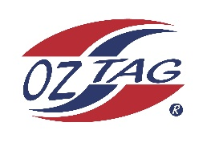
2022 Sutherland Shire Stingrays
Under 13 Girls Representative squad
Australian National Championships Cup Coffs Harbour

Congratulations to the following players selected in the under 13 girls to represent Sutherland Shire Stingrays.

1 | Kalani Anderson
2 | Eva Benton
3 | Emeline Bourke
4 | Ocean Bradley
5 | Brooke Carroll
6 | Noa Coupland
7 | Paige Debreczini
8 | Amalee Doyle
9 | Dolly Fava
10 | Haylee Hanley
11 | Lyla Hawksworth
12 | Rhianna Karika
13 | Ashleigh L’Estrange
14 | Monique Marshall
15 | Saige Pritchard
16 | Tahli Weigand
 | Shadows in no particular order
17 | Kalarni Judd
18 | Taylor Galloway
19 | Emily Rebeiro
20

Division: 13 girls

Coach/s: Kim Carroll
Phone:0408115350
Email:

Manager:
Phone:
Email:

