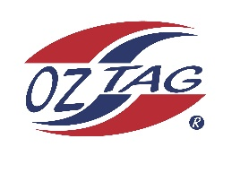
2022 Sutherland Shire Stingrays
Under 16 Girls Representative squad
Australian National Championships Cup Coffs Harbour

Congratulations to the following players selected in the under 16 girls squad to represent Sutherland Shire Stingrays.

1 | Chloe Benton
2 | Brooke Campbell
3 | Sienna Davey
4 | Sienna Greck
5 | Ava Hardy
6 | Chyna Hardy
7 | Lily Hill
8 | Ryley Hulburt
9 | Marnie Ismonger
10 | Tegan Jenkins
11 | Ava Kimmorley
12 | Kobe Maher
13 | Scarlett Salib
14 | Freya Scully
15 | Tahli Struthers
16 | Sophie Weppler
 | Shadows (in no particular order)
17
18
19
20

Division: Girls 16

Coach/s: Jordan Hollis & Angela Davey
Phone:0404 494 440
Email: angdavey72@gmail.com

