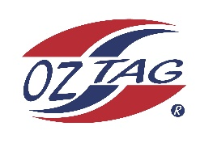
2022 Sutherland Shire Stingrays
Under 17 Girls Representative squad
Australian National Championships Cup Coffs Harbour

Congratulations to the following players selected in the under u/17 Girls squad to represent Sutherland Shire Stingrays.

1 | Sienna Arthur
2 | Tahli Bailey
3 | Demi Bresnahan
4 | Jasmin Brown
5 | Ava Cahill
6 | Tess Corbett
7 | Caitlin Gibbs
8 | Olivia Herman
9 | Kira Hensley
10 | Sophie Kay
11 | Tiana Martin
12 | Elle Mercer
13 | Christie Natoli
14 | Alena Pale Eli
15 | Tess Robinson
16 | Jade Tattam
 | Shadows (in no particular order)
17 | Claire Steghauer
18 | Jane Crosser
19
20

Division: u/17 Girls

Coach/s: Brad Tattam
Phone: 0403130139
Email: tattam@optusnet.com.au

Manager: Angela Bresnahan
Phone: 0410660749
Email: angelabresnahan@mcgrath.com.au

