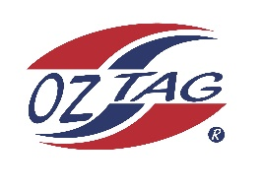
2022 Sutherland Shire Stingrays
Under 9 Girls Representative squad
Australian National Championships Cup Coffs Harbour

Congratulations to the following players selected in the under 9 Girls squad to represent Sutherland Shire Stingrays.

1 | Liberty Athos
2 | Havana Pallister
3 | Ruby Somerville
4 | Lily Rikihana
5 | Mayah Tanko
6 | Scarlett Tracy
7 | Koa Barbuto
8 | Cleo Eldson
9 | Abigail O’Flynn
10 | Victoria Trajcevski
11 | Eva Anasis
12 | Ella Sweeney
13 | Chloe Punn
14 | Mia Cooper
15 | Chloe Lucas
16 | Daisy Lopez
 | Shadows (in no particular order)
17 | Sia Owsnett
18 | Jemima Punn
19 | Indra Stevens
20 | Zahli Bates

Division: 9 Girls

Coach/s: Chad & Kelly Barbuto
Phone: 0408 632 286 or 0404 354 579
Email: kelflemo@hotmail.com

Manager: TBC
Phone:
Email:

