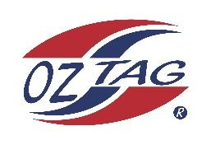

2023 Sutherland Shire Stingrays
Under Boys 14 Representative

Congratulations to the following players selected in the under 14 Boys team to represent Sutherland Shire Stingrays.

 | Name
1 | Dash Delaney-Fielding
2 | Jayden Best
3 | Kaden Anthony
4 | Kade Wilson
5 | Xavier Young
6 | Hamilton Kingi
7 | Charlie Rap
8 | Tyler Bowran
9 | Lucas Cousemacker
10 | Ashton Carrol
11 | Fletcher Brown
12 | Ziggy Hughes
13 | Benji Halloran
14 | Brodie Dorahy
15 | Curren Taper
16 | Marshal Anderson
17 | Zac Redman
18 | Noah Kenedy
19
20

Division: 14 Boys
Coach/s: Drew Cousemacker, Cain Best
Phone: 0416155338, 0418263742
Email: drew@cousemackergroup.com.au

Manager: Shelly Edmonds
Phone: 0407439122
Email:

