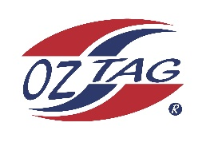

2023 Sutherland
Under 10 Boys Representative

Congratulations to the following players selected in the under 10s squad to represent Sutherland.

1 | Austin Howard
2 | Beau Green
3 | Bodhi Moyle
4 | Cooper Walsh
5 | Cruz Hansell
6 | Jack Dooley
7 | James Rodway
8 | Jamie Vargas
9 | Kieran Eisenhuth
10 | Lawson Howes
11 | Noah Van Dyk
12 | Orlando Latimore
13 | Remy Goodwin
14 | Remy Wells
15 | Tommy Miller
16 | Zane Ferguson
 | Shadows (in no particular order)
17 | Connor O’Keefe
18 | Hunter Brenton
19 | Max Geisker
20

Division: Sutherland

Coach/s: Jeremy Latimore
Phone: 0422271983
Email: lats1986@gmail.com

Manager: Jason Wells
Phone: 0439981476
Email:

