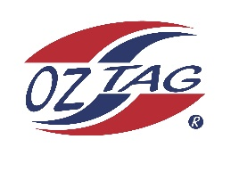

2023 Sutherland
Under 12 Boys Representative

Congratulations to the following players selected in the under ___12’s_____ squad to represent Sutherland.

Name
1 | Finn Bates
2 | Isaac Bevan
3 | Ryder Dowley
4 | William Diment
5 | Drea Goodwin
6 | Lachlan Hennessy
7 | Ryan Howard
8 | Harrison Kelly
9 | Tyler Milton
10 | Rory O'Brien
11 | Rock Reddy
12 | Sebastian Rodway
13 | Xavier Terides
14 | Jacob Walton
15 | Jax Wells
16 | Darcy Wilson
 | Shadows (in no particular order)
17 | Braxton Horsnell
18 | Mason Moyle
19
20

Division:

Coach/s:
Phone:
Email:

Manager:
Phone:
Email:

