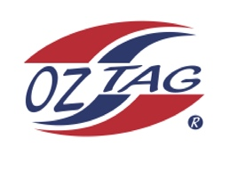
Boys Under 9 Sutherland State Cup Representative Team 2023

Congratulations to the following players selected in the 2023
Sutherland representative team

1. | Marat Spence
2. | Cody Marjoram
3. | Isaac Milton
4. | Brayden Yusuf
5. | Axle Perrie
6. | Archie Herb
7. | Duke Vaotuua
8. | Chace Scott
9. | Jasper Terides
10. | Bailey Thatcher
11. | Ashton Bridgman
12. | Nash Sherwin
13. | Gus Miller
14. | Jake Fanning
15. | Harry Whitton
16. | Billy Bates

To accept your position please text/email the coach
By Friday 18th November 2022

Coach. Kali Herb Mobile. 0419600556

Email Kali.burns2@det.nsw.edu.au

Manager. __________________________ Mobile_______________________

Email ________________________________________________________

Email ____________________________________________________________

