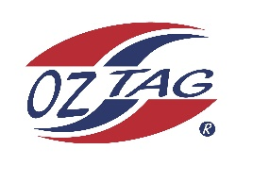

2023 Sutherland
Under 10 Girls Representative

Congratulations to the following players selected in the under 10 Girls squad to represent Sutherland.

1 | Eva Anasis
2 | Koa Barbuto
3 | Ella Sweeney
4 | Roxy Hulbert
5 | Lily Rikihana
6 | Indra Stevens
7 | Chloe Lucas
8 | Zahli Bates
9 | Chelsea Ewings
10 | Havana Pallister
11 | Daisy Lopez
12 | Scarlett Tracy
13 | Cleo Eldson
14 | Jade Barlow
15 | Miley Ryan
16 | Ella Farmer
 | Shadows (in no particular order)
17 | Lillian Barry
18 | Emily Humphrey
19 | Neha Sakaria
20

Division: Under 10 Girl’s

Coach/s: Kelly Barbuto
Phone: 0404 354 579
Email: kelflemo@hotmail.com

Manager: TBC
Phone:
Email:

