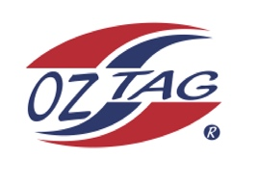
Girls Under 15 Sutherland State Cup Representative Team 2023

Congratulations to the following players selected in the 2023
Sutherland representative team

1. | Nova Batman
2. | Madison Brown
3. | Grace Cramsie
4. | Phoenix Green
5. | Martha Gregory
6. | Ruby Hedley
7. | Sarah Hickey
8. | Riley Hodge
9. | Abbie Jackson
10. | Zara Loveday
11. | Chloe Ozolins
12. | Hannah Silver
13. | Tara Skelton
14. | Bronte Snoxall
15. | Sienna Wilson
16. | Charlotte Woolnough
 | SHADOWS (IN NO PARTICULAR ORDER)
 | Jaeva Bentley
 | Jade Murphy

To accept your position please contact the coach
By Friday November 18th

Coach: Shane Hedley Mobile 0409 464 220
Email: shane@hedleyaccounting.com.au

Asst Coach: Louise Silver Mobile 0403 649 160
Email: slsilver@bigpond.com

Manager: Cheryl Woolnough Mobile 0433 315 537
Email: mcwoollie@bigpond.net.au

